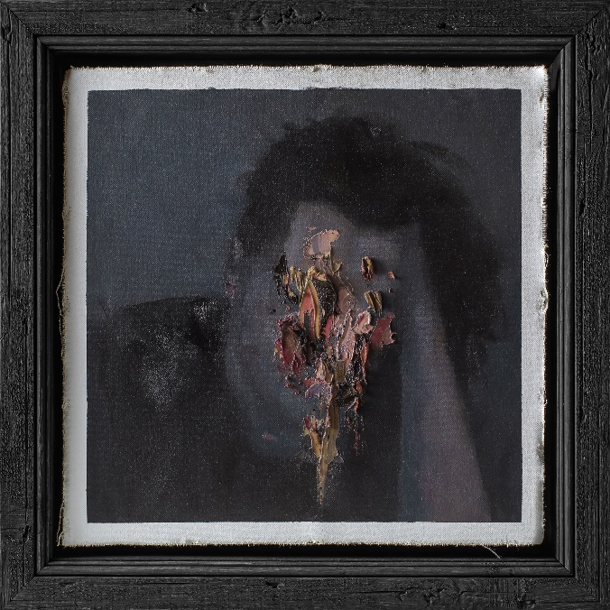

CONJURER

» Páthos «

OUT: July 1st 2022
Line up: | CONJURER online:
Brady Deeprose | Guitars, Vocals  Dan Nightingale | Guitars, Vocals  Conor Marshall | Bass  Jan Krause | Drums | https://www.instagram.com/conjureruk/  https://twitter.com/ConjurerUK  https://www.facebook.com/conjureruk
The future of British metal lies in safe hands with CONJURER, who continue their journey as the country’s most exciting young metal band with their incredible new album Páthos (Nuclear Blast).
A triumphant return from CONJURER following their world-renowned 2018 debut Mire, Páthos is a band flexing their creative muscles, deepening their approach and thought, and expanding their sound.
Opener ‘It Dwells’ is the perfect introduction – earth-shatteringly heavy, unconventional, uniquely beautiful, and instantly recognisable as CONJURER. The track is centred on the contradictions of the emotion of ‘fear’ – that fear can be comfortable and constant, haunting and crushing. It builds to a point of breaking – the need to end fear battling against your will to go on. The repeated screams ‘I’ll have peace’ are an ambivalent declaration of defiance – give in, or fight, either way fear is gone.
Track two ‘Rot’ continues this theme – a lumbering monster of a song, it’s a conversation between a person’s sense of self and their anxieties. As the song progresses both perspectives unify – the ‘I’ becoming ‘we’, the two halves becoming one. It’s a tortured, battered listening experience, and a blistering reminder of why the young band have become so praised so quickly.
Páthos is not an album for the half-hearted or faint-hearted. Elements of Sumac, Gojira, old Mastodon and Sumac, the new record is a multi-layered beast – sludge, death, doom, black metal and hardcore influences clash and collide throughout, all masterfully finished by Will Putney’s exquisite production.
The fifty-minute runtime of Páthos is not without it’s moments of the sublime. Post-metal nods to CONJURER and PIJN’s acclaimed Curse These Metal Hands project are heard throughout, most notably in track three, ‘All You Will Remember’, and the mighty, philosophical closer ‘Cracks In The Pyre’.
An suitably open-ended climax, Páthos ends with an expansive look at loss and the afterlife. That a band can be at once so triumphantly beautiful and gut-punchingly heavy is testament to CONJURER’s quality, and a surefire sign of their future longevity at the top of Britain’s heavy music scene.
CONJURER’s debut full-length Mire (2018) was released to a storm of attention from across the metal world, garnering significant acclaim from Metal Hammer UK, Kerrang!, BBC R1, Visions Mag (DE), MetalSucks, Metal Injection, Loudwire and many more. Recipients of award nominations (Kerrang!, Heavy Music Awards, Metal Hammer’s Golden Gods) and countless albums of the year lists, Mire is a stunning listen, capturing the attitude of a young band who already know exactly who they are.
Hailed as one of the metal world’s most devastating, thrilling experiences, CONJURER are a band never content to rest. Following Mire’s release in 2018 the quartet soon toured Europe for the first time, appeared at multiple UK festivals, and support of doom titans Conan and Will Haven.
In the following years the band have toured the US twice, supporting Rivers of Nihil (stopping to record an Audiotree session along the way), and then Voivod, with Revocation. 2019 also saw CONJURER’s debut Download Festival appearance, thrilling a packed-out Dogtooth stage, and the release of the joyous collaborative project with Pijn, titled Curse These Metal Hands.
It was only at the end of 2019 that CONJURER closed out their triumphant Mire cycle, with a sold-out UK run – their debut headline tour. Using the COVID-19 pandemic to record and craft Páthos, CONJURER returned to the live setting performing at the Download Pilot 2021 and Bloodstock 2021 mainstages.

